OS Lab 8

11762 Muhammad Kashif

Task 1

#include <stdio.h>

#include <unistd.h>

#include <stdlib.h>

#include <pthread.h>

void *thread_function(void*);

pthread_mutex_t mutex1 = PTHREAD_MUTEX_INITIALIZER;

int counter =0;

int count = 0;

int array[20]= {1,5,7,10,12,14,15,18,20,22,25,27,30,64,110,220,23,657,43,2};

int main(){

pthread_t thread_id[5];

int iret[5];

for(int i=0;i<5;i++){

pthread_create(&thread_id[i],NULL,thread_function,NULL);

sleep(5);}

return 0;}

void *thread_function(void *){

pthread_mutex_lock(&mutex1);

printf("Please Enter a number: ");

scanf("%d",&counter);

for(int i; i <20; i++){

if(array[i] == counter){

count++;}}

if(count == 1){

printf("Search number Found\n");}

else{

printf("Search number not Found\n");}

count = 0;

pthread_mutex_unlock(&mutex1);}

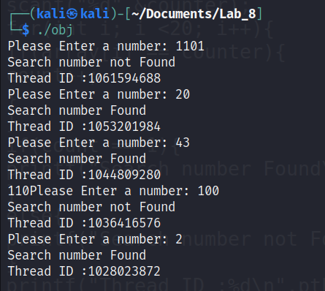Output